

DMS Renovation
Software Requirement Specification

Project Code: DMS1
Document Code: DMS1_SRS_DefectManagement_v1.0

Ho Chi Minh, May 2014

Record of change

*A - Added M - Modified D - Deleted
Effective Date | Changed Items | A*  M, D | Change Description | New Version
01-May-14 | First release | A |  | 1.0

SIGNATURE PAGE

ORIGINATOR: Vo Quoc Bao 01-May-14

REVIEWERS:

APPROVAL:

Table of content
Table of content 4
1.1. Defect View Or Edit screen 4
1.2. Batch Update Defect screen 11
1.3. Export Defect 14
1.4. Defect lifecycle 17
2. Others requirement 19
2.1. Header of page 19
2.2. Data Format 21
2.3. Order of reference data 21
2.4. Timeout requirement 27
2.5. Message list 27

  - Defect View Or Edit screen
    - Overview
With this function, user can update existed defect and save the modification. All members of project can update the defect.
    - Actors
All project members can update defect.
    - Use-case diagram
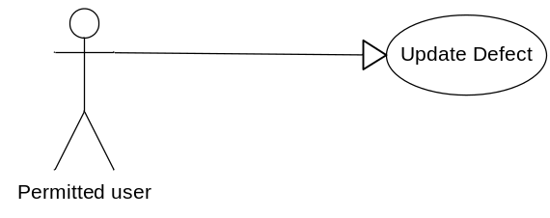
      - Pre-condition
User must be logged-in the system.
      - Post-condition
N/A
      - Triggers
    - User clicks on Defect ID in defects list screen
    - Workflows
Actor | System
1. Go to “Defect View Or Edit” screen | 2. Display “Defect View Or Edit” screen with all available data fields related to a specific actor  Display current values of defect for user to update
3. Update value of data fields & click “Save” button | 4. Validate data fields  If all fields are valid, defect will be updated in database and go to the page “Defect List”
    - External interfaces
      - Prototype
Defect View Or Edit
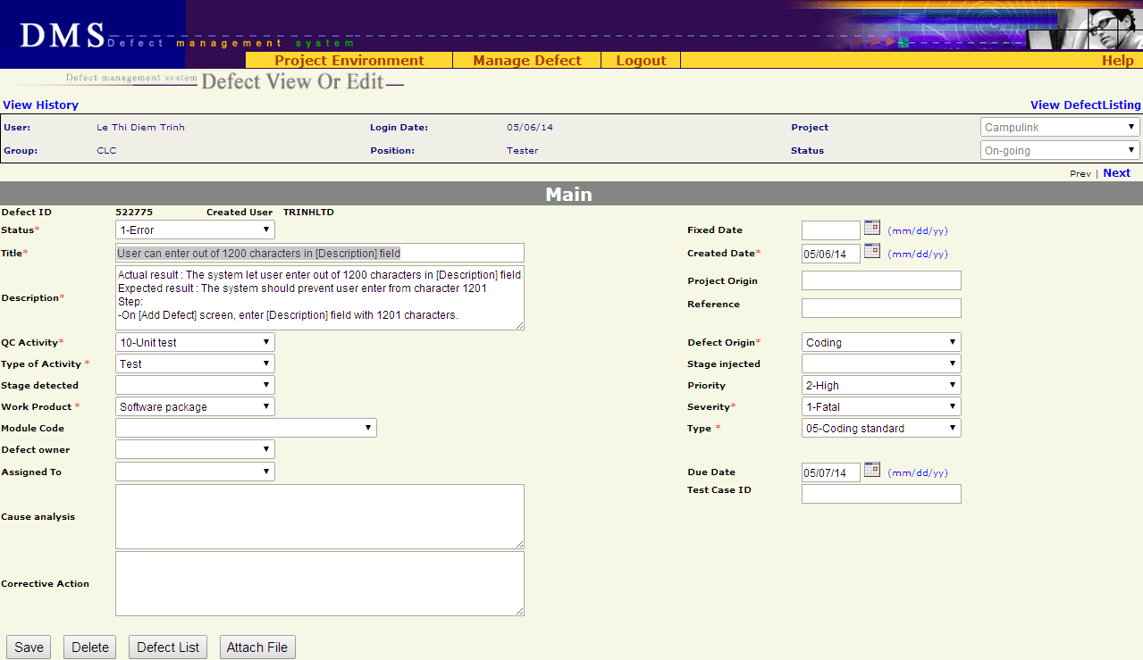
      - Screen descriptions
No | Field name | Control Type | Required | Data type | Default value | Description

Defect detail
1 | Status | Label | Yes | Text | Current Value | Status of the defect.
2 | Fixed Date | Text field | No | Date | Blank | Date when the defect was fixed  Date format mm/dd/yy
3 | Title | Text field | Yes | Text | Current Value | A short & brief description of the defect for quick recognition
4 | Created Date | Text field | Yes | Date | Current Value | Date when the defect was recorded in DMS  Date format mm/dd/yy
5 | Description | Text area | Yes | Text | Current Value | Full description of the defect, often the steps to reproduce the defect
6 | Project Origin | Text field | No | Text | Current Value
7 | Reference | Text field | No | Text | Current Value
8 | QC Activity | Combo box | Yes | Text | Current Value | QC activity in which the defect is found
9 | Defect Origin | Combo box | Yes | Text | Current Value | Process of defect
10 | Type of activity | Combo box | Yes | Text | Current Value | Defect type of current project
11 | Stage Injected | Combo box | No | Text | Current Value | Stage injected of current project
12 | Stage Detected | Combo box | No | Text | Current Value | Stage detected of current project
13 | Priority | Combo box | No | Text | Current Value | Indicate how urgent the defect needs to be fixed
14 | Work Product | Combo box | Yes | Text | Current Value | Work product in which the defect is found. It is high level CI
15 | Severity | Combo box | Yes | Text | Current Value | Severity of defects in current project
16 | Module Code | Combo box | No | Text | Current Value | Module of defect in current project
17 | Type | Combo box | Yes | Text | Current Value | Type of defect
18 | Defect Owner | Combo box | No | Text | Current Value | List all members of the project.
19 | Assigned To | Combo box | No | Text | Current Value | List all members of the project.  If combo box “Assigned To” is chosen, status will be changed to Assigned by system
20 | Due Date | Text field | No | Date | Current Value | Deadline of defect fixing.  Date format mm/dd/yy
21 | Cause Analysis | Text area | No | Text | Current Value | Description of the cause of defect
22 | Test Case ID | Text field | No | Text | Current Value | ID of test case in which the defect was found  Maximal 50 characters
23 | Corrective Action | Text area | No | Text | Current Value | Actions/steps to correct the defect

Button
24 | Save | Button | N/A | N/A | N/A | Save current defect to database and return to “List defect” screen
25 | Delete | Button | N/A | N/A | N/A | Delete current defect
26 | Defect list | Button | N/A | N/A | N/A | Return to “Defect List” screen corresponding to previous selected query (All defects / All Open Defects / All Leakage Defects / Public or Private Query)
27 | Attach file | Button | N/A | N/A | N/A | Submit the defect to “Attach file” screen
    - Business descriptions
No | Name | Description
Defect detail
1 | Assigned To | User can choose any member of project
2 | Module Code | Available values are automatically got from another Project management tool  From this available values, list all appropriated “Modules” of “Work Product”
3 | Type | List all defect types of system
4 | Title | Can be updated by all members of project
5 | Description | Can be updated by all members of project
6 | Defect Owner | List all members of team that are assigned to project
7 | Due Date | Default value is today+1 if there is no value for this field
8 | Title | Focus on Defect Title item at the first load
9 | Corrective Action | If Status is changed to “3-Pending”, “4-Tested”, “5-Accepted” or “6-Cancelled” then “Corrective Action” must be filled.
Button
10 | Save | Validate all fields  If all fields are valid, save the defect in database and go to “Add Defect” screen. Save all information in Update screen including comment (if any)
11 | Delete | Delete the defect from database and go to “Defect List” screen.
12 | Defect List | Move to “Defect List” screen
13 | Attach file | Only Created user, Assignee and full-right users (PM, PTL, QA) can use this functionality  Submit the defect to “Attach file” screen
    - User-Validation rules
No | Validation rule | Error message ID
1 | Combo box is required | ERR_REQUIRED_STATUS  ERR_REQUIRED_QC_ACTIVITY  ERR_REQUIRED_DEFECT_ORIGIN  ERR_REQUIRED_TYPE_ACTIVITY  ERR_REQUIRED_WP  ERR_REQUIRED_SEVERITY  ERR_REQUIRED_TYPE
2 | Date format mm/dd/yy | ERR_FORMAT_DATE_CREATED  ERR_FORMAT_DATE_FIXED  ERR_FORMAT_DATE_DUE
3 | Text field/text area is required | ERR_REQUIRED_TITLE  ERR_REQUIRED_CREATED_DATE  ERR_REQUIRED_DESCRIPTION
4 | Created date is greater than current date | ERR_CONSTRAINT_DATE_CREATED_TODAY
5 | Fixed date is greater than current date | ERR_CONSTRAINT_DATE_FIXED_TODAY
6 | Created date is greater than fixed date | ERR_CONSTRAINT_DATE_CREATED_FIXED
    - Related use-cases
- List defect
- Attach file

  - Batch Update Defect screen
    - Overview
This function permit user to update concurrently some defects of the same batch. User must select defects from List Defect screen before using Batch Update.
    - Actors
All users who have permission on Batch update functionality (defined in RMS)

    - Use - case diagram
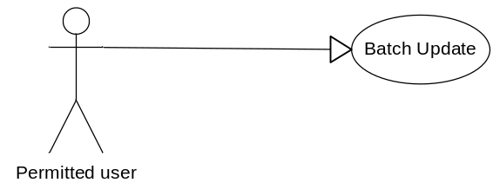
      - Pre-condition
- The actor has successfully logged into the system.
- User has selected at least one defect to update
      - Post-condition
N/A
      - Triggers
From List Defect screen, user selects some necessary defects for updating and clicks on Batch Update button.
    - Workflows
      - Scenario – Batch update
Actor | System
1. From List Defect screen, user selects some necessary defects for updating
2. User clicks on Batch Update button. | 3. Display Batch Update screen
4. User change some necessary fields of the selected defects
5. User clicks on Save button | 6. Save all modifications and return to List Defect screen.
    - External interfaces
      - Prototype
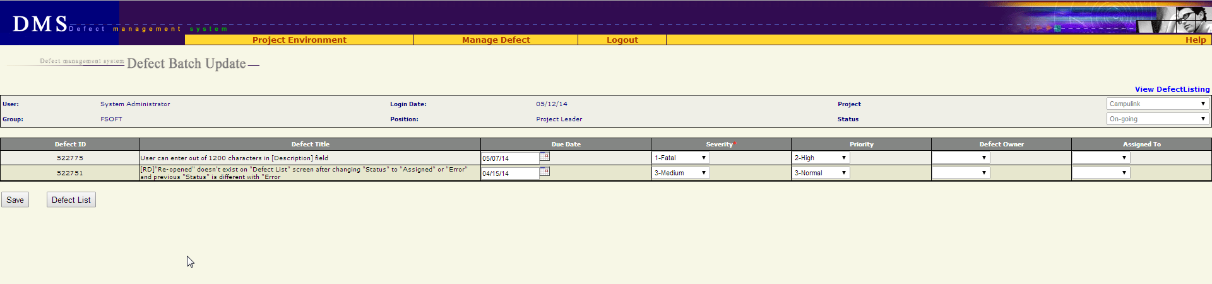
      - Screen Description
Each defect is listed here with following information:
No | Field name | Control type | Data type | Default value | Require | Functional Description/(*) Tool tips
1 | Defect ID | Label | Text | Copy from previous | N/A | ID number of defect  Cannot be edited
2 | Defect Title | Label | Text | Copy from previous | N/A | This is a brief description about defect  Cannot be edited
3 | Due Date | Text box | Text | Copy from previous | No | This is the date on which the defect should be fixed  - Associated with a date picker calendar  - format dd/mm/yy
4 | Severity | Combo box | Text | Copy from previous | Yes | Severity of defect
5 | Priority | Combo box | Text | Copy from previous | No | Priority of defect
6 | Defect Owner | Combo box | Text | Copy from previous | No | This field indicates who is owner of the defect  List all members of the project
7 | Assigned to | Combo box | Text | Copy from previous | No | This field indicates who will be responsible for fixing the defect  List all members of the project
    - Business Description
      - Data fields
No | Name | Business rules
1 | Defect Owner | User can assign owner for defect to any member of project
2 | Assigned To | User can assign defect to any member of project
      - Control area
No | Name | Business rules
1 | From List Defect screen, user clicks on Batch Update button | Go to Batch Update screen with the list of selected defects
2 | At Batch Update screen, user clicks on Defect List button | Return to List Defect screen without saving any thing
3 | User clicks on Save button | Save all changes and return to List Defect screen
    - User validation rules
No | Error type | Message Code
1 | Due date is in invalid format | ERR_FORMAT_DATE_DUE
    - Related use-cases
- Defect List

  - Export Defect
    - Overview
This screen allows user to export defects list retrieved from “Defect List” screen.
    - Actors
All users who has permission on Export functionality
    - Use-case diagram
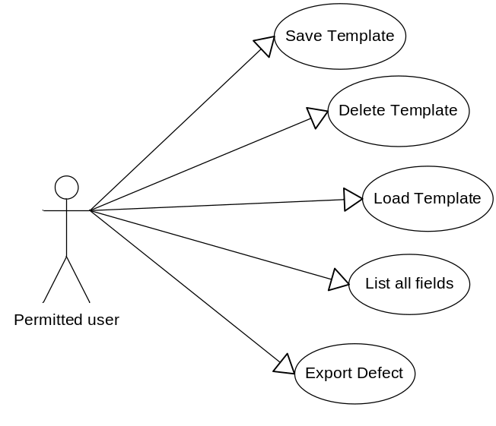
      - Pre-condition
User must be logged-in.
      - Post-condition
Defects were exported to a file.
      - Triggers
In “Defect List” screen, user click “Export” button.
    - Workflow
Actor | System
1/ Click “Export” button from “Defect List” screen | 2/ Defect which are being displayed in “Defect List” is exported  The exported file is saved in download link of browser.  Type of file: excel
    - External interfaces
      - Prototype
Defect is exported to excel file
      - File description
No | Field name | Description
1 | #
2 | DefectID
3 | Title
4 | Test Case ID
5 | Severity
6 | Priority
7 | Status
8 | Defect Owner
9 | Assign To
10 | Created By
11 | Create Date
12 | Fixed Date
13 | Due Date
14 | Description
15 | Project Origin
16 | Reference
17 | QC Activity
18 | Defect Origin
19 | Activity Type
20 | Stage Injected
21 | Stage Detected
22 | Work Product
23 | Module
24 | Defect Type
25 | Corrective Action
26 | Closed Date
27 | Cause Analysis
    - User – validation rules
No | Name | Message Code
1 | Export list is empty | ALT_REQUIRED_EXPORT_LIST
    - Related use-cases
- Defect List

  - Defect lifecycle
Defect lifecycle:
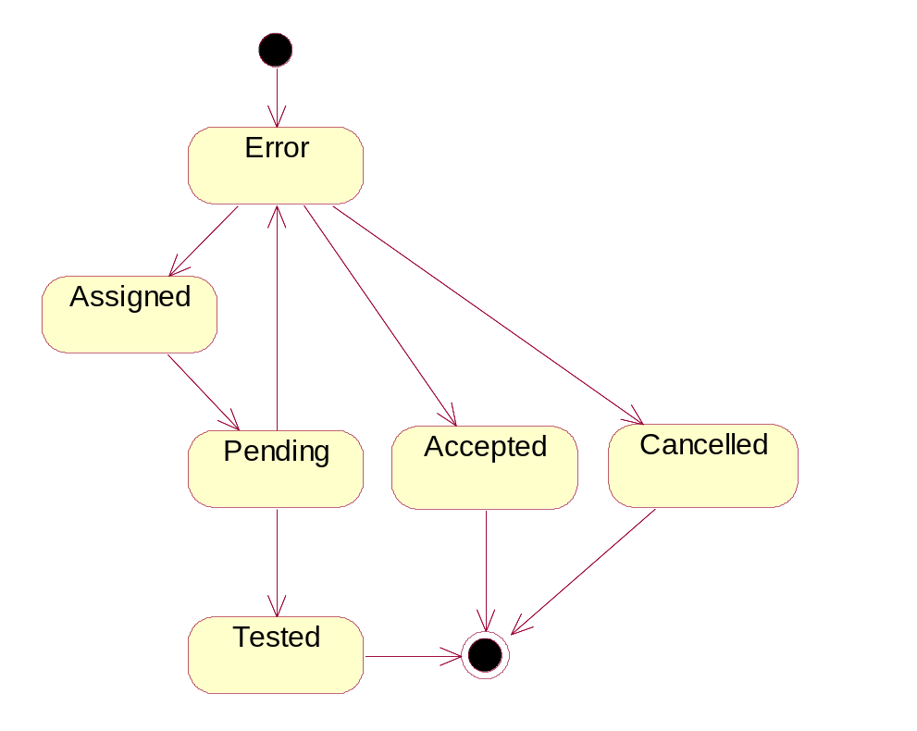
Figure 2.1.1: Defect life cycle

Description:
- A problem is logged into DMS -> status = Error
- PM/PTL verify the logged problem
  - It’s really a bug - assign to Developer fix -> change status = Assigned
  - It’s NOT a bug -> change status = Cancelled
  - It’s really a bug but no need fix at this project (by any reason) -> change status = Accepted
- Developer fix bug -> change status = Pending
- Tester verify bug again
  - Bug is really fixed -> change status = Tested
  - Bug is NOT fixed yet -> change status = Error again

Current status |  |  | Next status
Relationship | 1-Error | 2-Assigned |  | 3-Pending | 4-Tested | 5-Accepted | 6-Canceled | End
1-Error |  | x |  |  |  | x | x
2-Assigned |  |  |  | x
3-Pending | x |  |  |  | x
4-Tested |  |  |  |  |  |  |  | x
5-Accepted |  |  |  |  |  |  |  | x
6-Cancelled |  |  |  |  |  |  |  | x

Others requirement
  - Header of page
    - Overview
Always display Header in all screens.
    - External interfaces
      - Prototype:
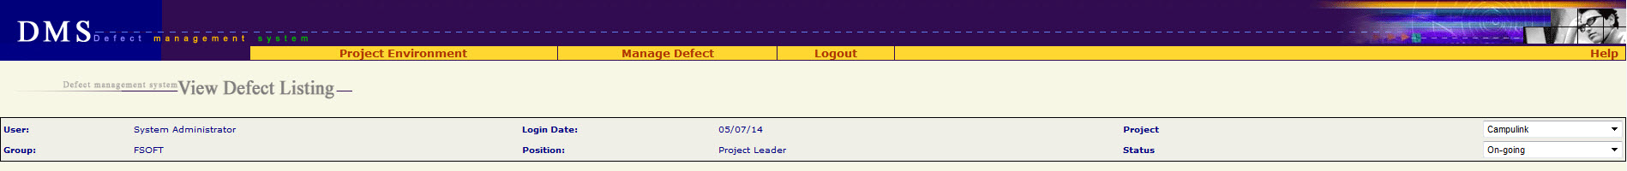
      - Screen description
No | Field name | Control type | Data type | Description
1 | Project Environment | Menu | Text
2 | Assign User | Menu | Text | Submenu of “Project Environment” menu
3 | Work Product | Menu | Text | Submenu of “Project Environment” menu
4 | Module | Menu | Text | Submenu of “Project Environment” menu
5 | Setup Environment | Menu | Text | Submenu of “Project Environment” menu
6 | Mange Defect | Menu | Text
7 | Manage Views | Menu | Text | Submenu of “Mange Defect” menu  Go to Home page
8 | New Defect | Menu | Text | Submenu of “Mange Defect” menu  Go to Add New defect screen
9 | Manage Planned Defect | Menu | Text | Submenu of “Mange Defect” menu
10 | Project Summary | Menu | Text | Submenu of “Mange Defect” menu
11 | Import Defect | Menu | Text | Submenu of “Mange Defect” menu
12 | Logout | Menu | Text | Logout system, go to Login screen
13 | Help | Menu | Text | Download & open file “Guideline_Defect Management System.doc”
14 | Defect management system <screen name> | Label | Text
15 | User | Label | Text | Value = type of login user
16 | Group | Label | Text | Value = group of login user
17 | Login Date | Label | Text | Value = today  Date format = mm/dd/yy
18 | Position | Label | Text | Role of login user
19 | Project | Combo box | Text | List of project which login user is assigned  Default value = the current project
20 | Status | Combo box | Text | Status of project  Default value = the current status of project

  - Data Format
    - Date/Time Format
Default date format is mm/dd/yy For example: 05/29/14
Default time format is hh:mm:ss For example: 07:23:55
    - Number Format
No zero at prefix
File size: xx.x KB For example: 192.3 KB
Available size: xx KB For example: 456 KB
Order number has no comma separated For example: 12345
Decimal places of % is 1 For example: 25.7%

  - Order of reference data
    - QC Activity
10-Unit test (Type of Activity = Test)
11-Integration test (Type of Activity = Test)
12-System test (Type of Activity = Test)
13-Acceptance test (Type of Activity = Test)
14-Regression test (Type of Activity = Test)
15-After release test (Type of Activity = Test)
16-Other test (Type of Activity = Test)
17-Prototype test (Type of Activity = Test)
20-Document review (Type of Activity = Review)
21-Code review (Type of Activity = Review)
22-After release review (Type of Activity = Review)
23-Prototype review (Type of Activity = Review)
24-Other review (Type of Activity = Review)
30-Quality gate inspection (Type of Activity = Inspection)
31-Final inspection (Type of Activity = Inspection)
32Other inspection (Type of Activity = Inspection)
33-UT inspection (Type of Activity = Inspection)
40-Baseline audit (Type of Activity = Audit)
41-Other audit (Type of Activity = Audit)
    - Defect Origin
Administration
Coding
Collaborator Management
Configuration Management
Contract Management
Correction
Customer Support
Deployment
Design
Document Control
Facility Management
IS Management
Internal Audit
Management Review
Other
Prevention
Process Improvement
Project Management
Quality Control
Quality Planning
Recruitment
Requirement
Retirement
Staff Management
Student Management
Subcontract Management
Technology management
Test
Training
    - Type of Activity
1. Review
2. Test
3. Inspection
4. Audit
    - Stage Injected / Stage Detected
<blank>
1-Initiation
2-Definition
3-Solution
4-Construction
5-Transition
6-Termination
Definition&Solution
Initiation&Definition
Release 1
Release 2
Release 3
Release 4
Release 5
Release 6
Solution&Construction
    - Priority
<blank>
1-Immediately
2-High
3-Normal
4-Low
    - Work product
Acceptance note
Architectural design
Audit program
Audit record
Audit report
Baseline Audit
Baseline report
CM Plan
Change request
Coding convention
Configuration Status Report
Contract
Customer Satisfaction Survey
DAR Report
DP Plan
DP report
Database
Deployment package
Design prototype
Detailed design
Final inspection
Handover note
IP
IP database
Installation manual
Integration test case
Integration test plan
Integration test report
Meeting minutes
Others
PCB
PQA report
Pilot plan
Pilot record
Pilot report
Plan
Process assets
Process database
Program
Project assests
Project database
Project plan
Project record
Project report
Proposal
Prototype
QA report
QA review record
QDS
Quality control report
Quality gate record
Record
Release note
Report
Requirement prototype
Resource and environment
Review TestCase
Review record
SQA report
SRS
Service Level Agreement
Software module
Software package
Support Diary
System description
System test case
System test plan
System test report
Test data
Test plan
Test script
Traceability matrix
Training course
Training material
Training records
URD
Unit test case
Unit test plan
Unit test report
Use case
User manual and WO
    - Severity
1-Fatal
2-Serious
3-Medium
4-Cosmetic
    - Module / Module Code
<Blank>
<List of module which got from another Project management tool>
    - Type
01-Functionality (Other)
011-Req misunderstanding
012-Feature missing
013-Coding logic
014-Business logic
02-User Interface
03-Performance
04-Design issue
05-Coding standard
06-Document
07-Data & Database integrity
08-Security & Access Control
09-Portability
10-Other
11-Tools
    - Defect owner, Assigned To,
All member of project are ordered by alphabet :
<Blank>
<Member 1>
…..
<Member n>
    - Status
1-Error
2-Assigned
3-Pending
4-Tested
5-Accepted
6-Canceled
  - Timeout requirement
All screens have timeout of 1 hour
After timeout, user has to re-login, and does his/her previous step by step once again.
  - Message list
Message Code | English Content
ERR_FORMAT_DATE_CREATED | Created Date is invalid
ERR_FORMAT_DATE_CREATED_FROM | "From Created Date" is invalid.
ERR_FORMAT_DATE_CREATED_TO | "To Created Date" is invalid.
ERR_FORMAT_DATE_FIXED | "Fixed Date" is invalid.
ERR_FORMAT_DATE_FIXED_FROM | "From Fixed Date" is invalid.
ERR_FORMAT_DATE_FIXED_TO | "To Fixed Date" is invalid.
ERR_FORMAT_DATE_DUE | "Deadline" is invalid.
ERR_REQUIRED_SEVERITY | "Severity" is required
ERR_REQUIRED_TYPE | "Type" is required
ERR_REQUIRED_TYPE_ACTIVITY | "Type of Activity" is required
ERR_REQUIRED_QC_ACTIVITY | "QC Activity" is required
ERR_REQUIRED_ORIGIN | "Defect Origin" is required
ERR_REQUIRED_WP | "Work Product" is required
ERR_REQUIRED_CREATED_DATE | "Created Date" is required
ERR_REQUIRED_TITLE | "Title" is required
ERR_REQUIRED_DESCRIPTION | "Description" is required
ERR_REQUIRED_STATUS | Ignore this message because status cannot be blank
ERR_REQUIRED_DEFECT_ORIGIN | Ignore this message because defect origin cannot be blank
ERR_DEFECT_ID_INVALID | Defect ID must be positive number
ERR_REQUIRED_ATTACHMENT_FILE | Please select at least one file to attach
ERR_FILE_OVER_AVAILABLE_SIZE | Attachment size exceeds available space
ERR_FILE_OVER_MAX_FILE_SIZE | Attach size exceeded
ERR_EXISTED_FILE_NAME | The attached file already exists!
ERR_CONSTRAINT_DATE_CREATED_FROMTO | "From Created Date" cannot be later than "To Created Date"
ERR_CONSTRAINT_DATE_FIXED_FROMTO | "From Fixed Date" cannot be later than "To Fixed Date"
ERR_CONSTRAINT_DATE_CREATED_TODAY | "Created Date" cannot be later than today
ERR_CONSTRAINT_DATE_CREATED_DUE | "Created Date" cannot be later than "Deadline"
ERR_CONSTRAINT_DATE_CREATED_FIXED | "Created Date" cannot be later than fixed date
ERR_CONSTRAINT_DATE_FIXED_TODAY | "Fixed Date" cannot be later than today
ALT_PAGE_INVALID | Your number is out of range
ALT_REQUIRED_DEFECT | Defect(s) is required
ALT_REQUIRED_EXPORT_LIST | Some items must be selected

